World Record Attempt

Class F (Aeromodels)
Sub-class F5-S (Aeroplane, electric motor, rechargeable sources of current)
Category: F5: Radio Controlled Flight
No 173: Gain in Altitude
Record Claim: 2,573 m (8441 ft), date 9/11/2003 - yet to be ratified.

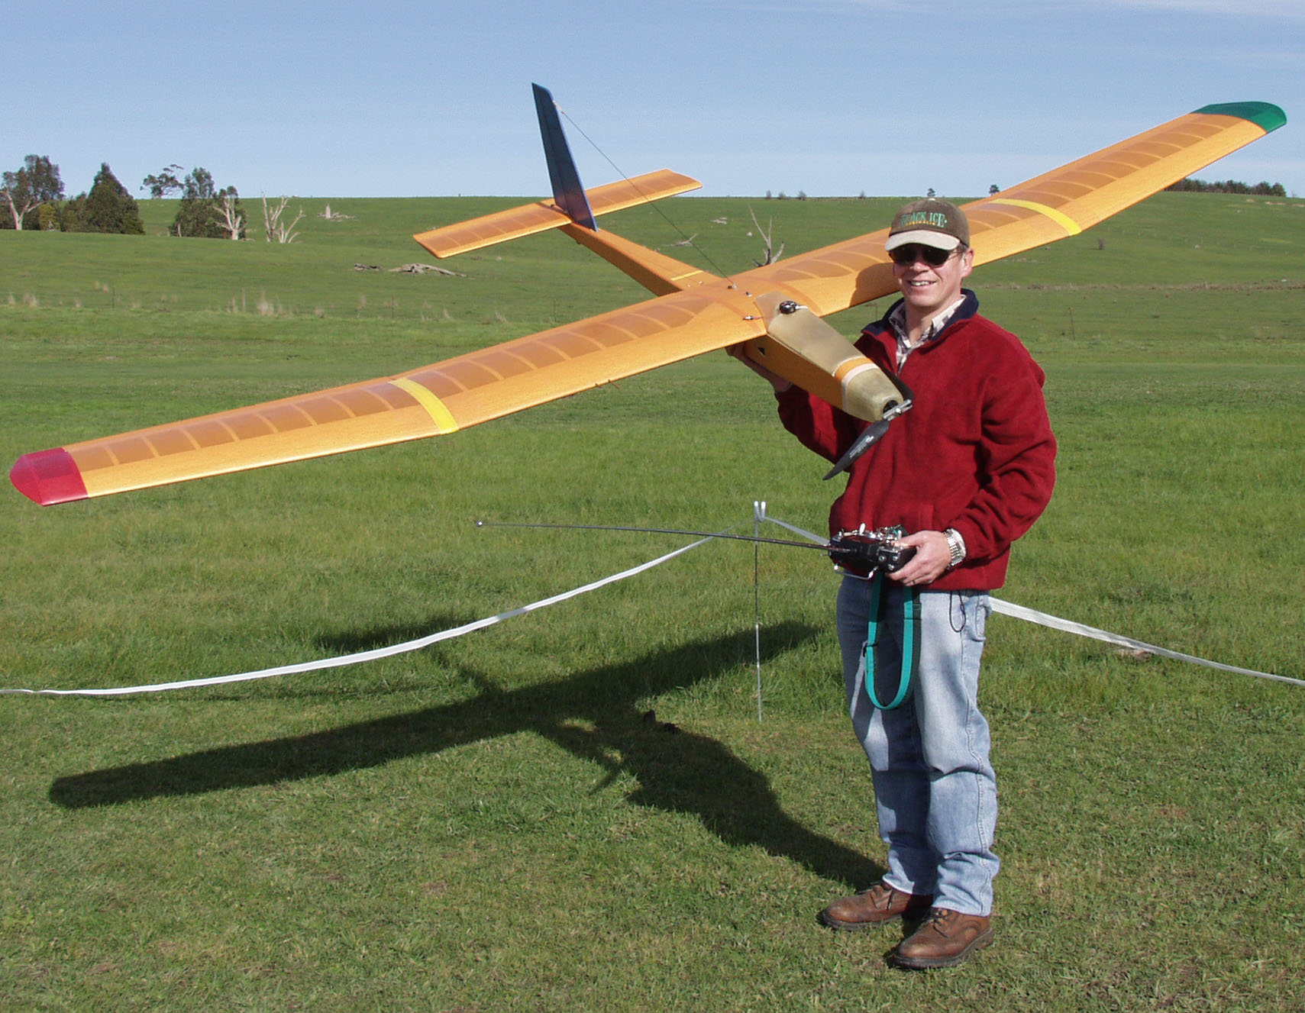

“Big Bird”

Photo courtesy Julie Bird

- Airframe: Construction is conventional - balsa, ply where needed, tissue covering, fibreglass hatch/cowl.
- Span: 328.8cm
- Root cord: 39.2cm
- Tip cord: 29cm
- Surface Areas: Wing 119dm sq, Tail 18dm sq
- Weight: 4200gms to 4940gms
- Motor: Actro 40/6 Brushless, 18.75" x 11" Prop
- Motor Battery: 9 series x 4 parallel eTech 1200 Lithium Polymer cells or 28 x GP3300 NiMh cells
- Radio Control system: JR 3810 TX, JR649PCM Rx, 6 x JR 381 servos
Controls: Elev, Rud, Ail, Flaps, Motor ESC (Co-Pilot infrared sensor for pitch stability)
- Climb Rate: Full throttle = 1300 ft per min approx., 70% Throttle = 700 ft per min (70% throttle used for record attempt)
Other Equipment:
- Head mounted binoculars, Bushnell 5 x 25 extra wide view
- Garmin eTrex GPS with barometric altimeter
- Also EMS Altitude Data logger as second barometric altimeter
- Data Capture card and Telemetry Module
Total flight time 31 minutes. (12 min ascent, 19 min descent)

Current World record is: 2'200 m (7218 ft)
Date of flight: 19/11/2000
Pilot: Wolfgang SCHAEPER (Germany)
Course/place: Markdorf (Germany)

